**AIM: NLP processing of any one Indian regional language.**

**THEORY:**

**POS Tagging:**

POS Tagging (Parts of Speech Tagging) is a process to mark up the words in text format for a particular part of a speech based on its definition and context. It is responsible for text reading in a language and assigning some specific token (Parts of Speech) to each word. It is also called grammatical tagging.

Example:

Input: Everything to permit us.

Output: [(‘Everything’, NN),(‘to’, TO), (‘permit’, VB), (‘us’, PRP)]

**Steps Involved in the POS tagging example:**

* Tokenize text (word_tokenize)
* apply pos_tag to above step that is nltk.pos_tag(tokenize_text)

**NLTK POS Tags Examples are as below:**

| **Abbreviation** | **Meaning** |
| --- | --- |
| CC | coordinating conjunction |
| CD | cardinal digit |
| DT | determiner |
| EX | existential there |
| FW | foreign word |
| IN | preposition/subordinating conjunction |
| JJ | This NLTK POS Tag is an adjective (large) |
| JJR | adjective, comparative (larger) |
| JJS | adjective, superlative (largest) |
| LS | list market |
| MD | modal (could, will) |
| NN | noun, singular (cat, tree) |
| NNS | noun plural (desks) |
| NNP | proper noun, singular (sarah) |
| NNPS | proper noun, plural (indians or americans) |
| PDT | predeterminer (all, both, half) |
| POS | possessive ending (parent\ ‘s) |
| PRP | personal pronoun (hers, herself, him, himself) |
| PRP$ | possessive pronoun (her, his, mine, my, our ) |
| RB | adverb (occasionally, swiftly) |
| RBR | adverb, comparative (greater) |
| RBS | adverb, superlative (biggest) |
| RP | particle (about) |
| TO | infinite marker (to) |
| UH | interjection (goodbye) |
| VB | verb (ask) |
| VBG | verb gerund (judging) |
| VBD | verb past tense (pleaded) |
| VBN | verb past participle (reunified) |
| VBP | verb, present tense not 3rd person singular(wrap) |
| VBZ | verb, present tense with 3rd person singular (bases) |
| WDT | wh-determiner (that, what) |
| WP | wh- pronoun (who) |
| WRB | wh- adverb (how) |

The above NLTK POS tag list contains all the NLTK POS Tags. NLTK POS tagger is used to assign grammatical information of each word of the sentence. Installing, Importing and downloading all the packages of POS NLTK is complete.

In Corpus there are two types of POS taggers:

* Rule-Based
* Stochastic POS Taggers

**1.Rule-Based POS Tagger:**For the words having ambiguous meaning, rule-based approach on the basis of contextual information is applied. It is done so by checking or analyzing the meaning of the preceding or the following word. Information is analyzed from the surrounding of the word or within itself. Therefore words are tagged by the grammatical rules of a particular language such as capitalization and punctuation. e.g., Brill’s tagger.

**2.Stochastic POS Tagger:**Different approaches such as frequency or probability are applied under this method. If a word is mostly tagged with a particular tag in training set then in the test sentence it is given that particular tag. The word tag is dependent not only on its own tag but also on the previous tag. This method is not always accurate. Another way is to calculate the probability of occurrence of a specific tag in a sentence. Thus the final tag is calculated by checking the highest probability of a word with a particular tag.

1. **POS TAGGING FOR ENGLISH LANGUAGE:**

**SOURCE CODE:**

import nltk

from nltk.corpus import stopwords

from nltk.tokenize import word_tokenize, sent_tokenize

nltk.download('punkt')

nltk.download('stopwords')

nltk.download('averaged_perceptron_tagger')

stop_words = set(stopwords.words('english'))

txt = "Sukanya, Rajib and Naba are my good friends. " \

  "Sukanya is getting married next year. " \

  "Marriage is a big step in one’s life." \

  "It is both exciting and frightening. " \

  "But friendship is a sacred bond between people." \

  "It is a special kind of love between us. " \

  "Many of you must have tried searching for a friend "\

  "but never found the right one."

# sent_tokenize is one of instances of

# PunktSentenceTokenizer from the nltk.tokenize.punkt module

tokenized = sent_tokenize(txt)

for i in tokenized:

  # Word tokenizers is used to find the words

  # and punctuation in a string

  wordsList = nltk.word_tokenize(i)

  # removing stop words from wordList

  wordsList = [w for w in wordsList if not w in stop_words]

  # Using a Tagger. Which is part-of-speech

  # tagger or POS-tagger.

  tagged = nltk.pos_tag(wordsList)

  print(tagged)

**OUTPUT:**

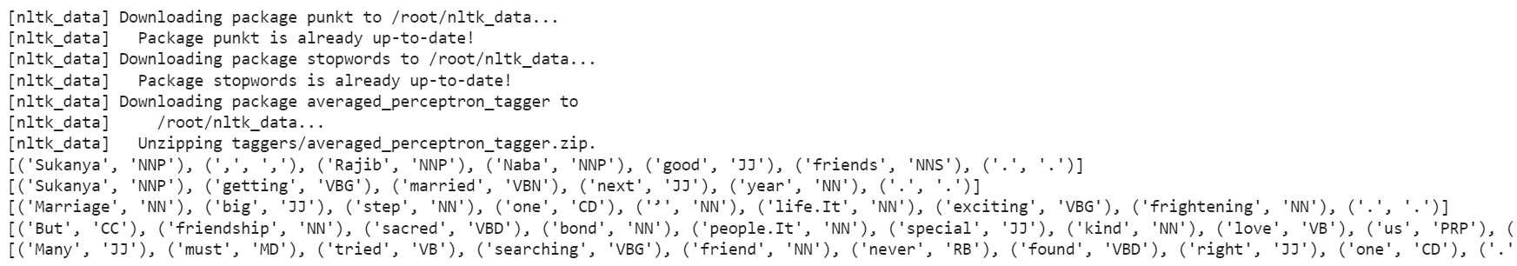

[('Sukanya', 'NNP'), (',', ','), ('Rajib', 'NNP'), ('Naba', 'NNP'), ('good', 'JJ'), ('friends', 'NNS'), ('.', '.')]

[('Sukanya', 'NNP'), ('getting', 'VBG'), ('married', 'VBN'), ('next', 'JJ'), ('year', 'NN'), ('.', '.')]

[('Marriage', 'NN'), ('big', 'JJ'), ('step', 'NN'), ('one', 'CD'), ('’', 'NN'), ('life.It', 'NN'), ('exciting', 'VBG'), ('frightening', 'NN'), ('.', '.')]

[('But', 'CC'), ('friendship', 'NN'), ('sacred', 'VBD'), ('bond', 'NN'), ('people.It', 'NN'), ('special', 'JJ'), ('kind', 'NN'), ('love', 'VB'), ('us', 'PRP'), ('.', '.')]

[('Many', 'JJ'), ('must', 'MD'), ('tried', 'VB'), ('searching', 'VBG'), ('friend', 'NN'), ('never', 'RB'), ('found', 'VBD'), ('right', 'JJ'), ('one', 'CD'), ('.', '.')]

1. **POS TAGGING FOR HINDI LANGUAGE:**

**SOURCE CODE:**

from nltk.tag import tnt

from nltk.corpus import indian

import nltk

import pandas as pd

import numpy as np

nltk.download('punkt')

nltk.download('indian')

text = "इराक के विदेश मंत्री ने अमरीका के उस प्रस्ताव का मजाक उड़ाया है , जिसमें अमरीका ने संयुक्त राष्ट्र के प्रतिबंधों को इराकी नागरिकों के लिए कम हानिकारक बनाने के लिए कहा है ।"

def hindi_model():

    train_data = indian.tagged_sents('hindi.pos')

    tnt_pos_tagger = tnt.TnT()

    tnt_pos_tagger.train(train_data)

    return tnt_pos_tagger

tokensHindi = nltk.word_tokenize(text)

print(tokensHindi)

model = hindi_model()

new_tagged = (model.tag(nltk.word_tokenize(text)))

#print(new_tagged)

array=np.array(new_tagged)

for i in array:

    print(i[0]," ==> ", i[1]," ")

**OUTPUT:**

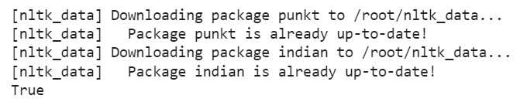['इराक', 'के', 'विदेश', 'मंत्री', 'ने', 'अमरीका', 'के', 'उस', 'प्रस्ताव', 'का', 'मजाक', 'उड़ाया', 'है', ',', 'जिसमें', 'अमरीका', 'ने', 'संयुक्त', 'राष्ट्र', 'के', 'प्रतिबंधों', 'को', 'इराकी', 'नागरिकों', 'के', 'लिए', 'कम', 'हानिकारक', 'बनाने', 'के', 'लिए', 'कहा', 'है', '।']

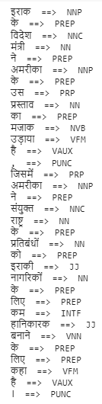

**CONCLUSION:**

From this practical, I have learned and implemented POS tagging of English and hindi language.